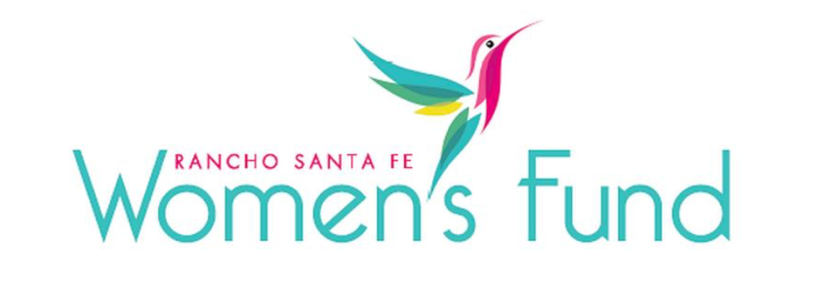

2023-24 Proposed Board Slate

Board Chair – Nikki Carmody Ream
Past Board Chair – Susan Hoehn
Grant Co-Chairs – Cathy Burch and Kathy Sage
Incoming Grant Co-Chairs – Maritia Walper* and Sara Bennett*
Past Grant Co-Chairs – Mara Buchholz and Nikki Carmody Ream
Membership Co-Chair – Cheryl Salmen* and Melissa D’Amour*
Finance Co-Chairs – Beth Terrana and Diane Solomon
Program Co-Chairs – Kirstjen Nielsen* and Muffy Walker*
Publicity Chair – Elia Surran*
Social Chair – Kelly Stroud*
Social Media Chair – Hazel Bentinck*
Technology Chair – Mara Buchholz
Volunteer Chair – Ellie Cunningham*
Members-at-Large – Cynthia Hudson*, Donna Vance*, Mary Consalvi*, Sandra Coufal* & Vivian Hardage*

* Board positions up for approval

