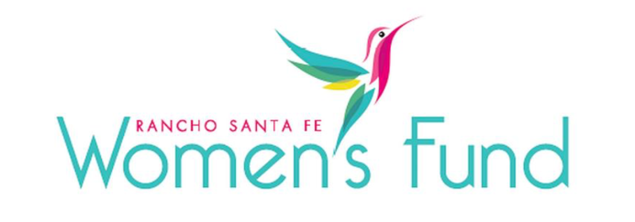

ORGANIZATION’S NAME: Casa de Amistad
PROJECT NAME: Kinder to College Study Companions Program: College and Career Pathways Program
ORGANIZATION’S WEBSITE: www.casadeamistad.org
PROJECT BUDGET: $239,274
AMOUNT REQUESTED FROM RSFWF: $50,000
ORGANIZATION’S ANNUAL BUDGET: $905,319

PROGRAM DESCRIPTION: Casa de Amistad’s College and Career Pathways Program provides free college and career preparation for first-generation low-income high school students. Approximately 126 middle and high school students will participate. Casa de Amistad has a cadre of dedicated college counselors who volunteer their time to help students prepare for and apply to college.

NEED/SOLUTION: Casa’s longstanding programming helps bridge the opportunity gap for students facing economic barriers to post-secondary education. Grant funding from the RSFWF will provide free academic mentoring, support college preparation, and provide invaluable opportunities for career exploration. College/Post-Secondary Application Preparation occurs every Thursday beginning in the winter of the junior year.

IMPACT: Students will complete an intensive college application preparation led by volunteer college counselors. These professional counselors help students get prepared for the college application process. During the summer months, the counselors help students in their process of drafting, editing, and completing their college entrance essays. Additionally, in the fall of their senior year, volunteer college counselors assist students in submitting their college applications and navigating the financial aid application process for these first-generation college students. Alternatively, these counselors also assist with any requirements to attend a vocational school if that is the student’s chosen path. Anticipated outcomes include 100% of the graduating class of Casa de Amistad high school seniors will enroll in post-secondary education.

Future Leader Scholarship Awards - The organization awards scholarships to all students who have participated in Casa programming for two consecutive years during high school and have a minimum 2.5 grade point average. The goal of The Future Leadership Scholarship is to eliminate a student’s need to take out student loans during the first two years of college and/or for a vocational school. Students attending a community college or vocational school are eligible for up to $600 each year to support expenses, while those attending a four-year university are eligible for up to $8,000 the first year and $4,000 the second year.

SITE VISIT DETAILS
RSFWF Site Visit Leader: Alchera Ayyad
Date/Time: Tuesday, March 5th at 1:00 PM

