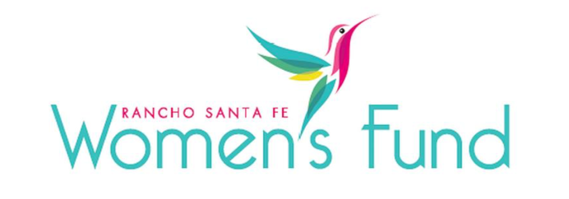

ORGANIZATION’S NAME: Center for Community Solutions
PROJECT NAME: Advocacy for Survivors of Intimate Partner Violence
ORGANIZATION’S WEBSITE: www.ccssd.org
PROJECT BUDGET: $1,123,331
AMOUNT REQUESTED FROM RSFWF: $35,000
ORGANIZATION’S ANNUAL BUDGET: $6,739,986

PROGRAM DESCRIPTION: Provide trauma-informed advocacy services for North County survivors of Intimate Partner Violence (IPV – often called domestic violence) and their families to decrease risk factors and promote protective factors related to future violence, economic instability, and long-term health consequences through individually tailored support, safety planning, accompaniment, and linkages to other supportive services.

NEED/SOLUTION: Due to the long-term impacts of IPV that survivors and their families endure, there is an essential need for trauma-informed advocacy services to establish immediate safety, begin healing, and decrease risk factors related to future violence, economic instability, and long-term health consequences. CCS provides individually tailored support, safety planning, accompaniment, and linkages to other supportive services. There are no other organizations in the North-Inland region of the County that provide this level of specialized support for IPV survivors and their recovery. Legal advocacy services are being impacted in 2024 due to the California Office of Emergency Services (Cal-OES)’s reduction in funding for these services, making the RSFWF funding critical to the continuation of CCS’ legal advocacy program.

IMPACT: CCS estimates they will serve approximately 2,379 individuals in the North County community with their
trauma-informed services for survivors, all of whom will receive advocacy services in order to address the root causes of IVP and DV and achieve long-term change, with an emphasis on legal advocacy. The estimated cost per participant is $472.19. The number of participants being impacted as a result of the RSFWF grant is 74 participants.

CCS will track IPV survivors and their families served and anticipate serving: -- 1500 North County callers to CCS' hotline will receive a safety plan and be provided linkages to supportive services; -- 400 individuals will receive peer-counseling provided by an Advocate/Certified DV Counselor; -- 100 individuals will receive legal assistance with TROs, protective and/or custody orders

SITE VISIT DETAILS
RSFWF Site Visit Leader: Joanne Marks
Date/Time: Friday, March 1st at 1:00 PM

