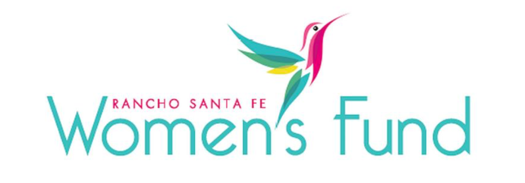

ORGANIZATION’S NAME: Elementary Institute of Sciences (EIS)
PROJECT NAME: Girl’s Take Flight
ORGANIZATION’S WEBSITE: www.eisca.org
PROJECT BUDGET: $130,155
AMOUNT REQUESTED FROM RSFWF: $25,000
ORGANIZATION’S ANNUAL BUDGET: $1,835,470

PROGRAM DESCRIPTION: Girls Take Flight is an innovative program for girls who are in 10th and 11th grade that provides hands-on experience building and flying drones, culminating with students becoming FAA-certified drone pilots.

NEED/SOLUTION: The target population is female high school students in the ethnically diverse, low-income communities of southeastern San Diego, City Heights, and Paradise Hills. These neighborhoods are most affected by deficits in STEM education. One hundred percent of the students meet the criteria for federal assistance. The ethnic breakdown of students served by EIS is 32 percent Hispanic, 21 percent African American, 23 percent Caucasian, 14 percent Asian/Pacific Islander, and 10 percent various other ethnicities.

Girls Take Flight is a program that encourages high school girls to pursue careers in engineering, aeronautics, and technology through Unmanned Aircraft Systems (UAS) – also known as drones. Students learn mechanical engineering and computer science skills in a supportive environment. It responds to the critical need to increase diversity in STEM industries. As the first drone program for high school females in the United States, it was a bold new venture that continues to innovate and improve with every cohort. It is also a new approach to a time-worn problem by combining skill attainment in a female-centric and female-led learning environment; it also addresses the issues and obstacles faced by women who enter male-dominated fields, particularly BIPOC women.

IMPACT: Since 2018, Girls Take Flight has served young women who are interested in the field of aeronautics. As of its fifth year of programming, 36 high school girls under the age of 18 have earned their FAA 107 Remote Pilot Certification. To date, every Girls Take Flight participant has enrolled in college after high school graduation, and 3 participants are currently pursuing commercial pilot careers. A $25,000 grant from the Rancho Santa Fe Women’s Fund will comprise approximately 19 percent of the budget for this program and will promote STEM careers for young women.

SITE VISIT DETAILS
RSFWF Site Visit Leader: Donna Vance
Date/Time: Wednesday, March 6th at 10:00 AM

