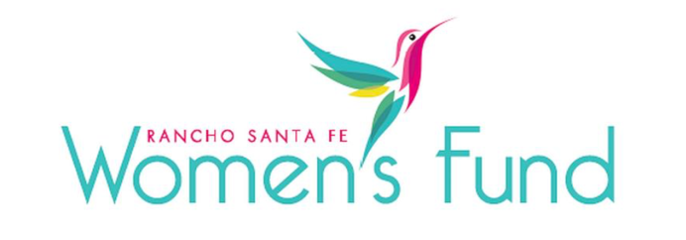

ORGANIZATION’S NAME: Girls, Inc. of San Diego County
PROJECT NAME: Empower HER
ORGANIZATION’S WEBSITE: www.girlsinc.org
PROJECT BUDGET: $$300,000
AMOUNT REQUESTED FROM RSFWF: $25,000
ORGANIZATION’S ANNUAL BUDGET: $627,000

PROGRAM DESCRIPTION: Empower HER is a comprehensive program model that incorporates lessons from across the STRONG, SMART, and BOLD program categories to equip girls with tools to improve their physical, emotional, and mental health.

NEED/SOLUTION: Girls today face vast and often intersecting challenges such as bullying, sexual harassment, barriers to academic and career success, unique health disparities, limited expectations, and stereotypes. Further inequalities associated with race, ethnicity, sexual orientation, gender identity, and socioeconomic status only exacerbate these issues. In San Diego County, women ages 18 to 34 are the largest demographic living in poverty, and 1 in 6 girls will not finish high school. There is a tremendous need for programming that focuses solely on girls and young women, preparing them to lead successful and independent lives. Girl’s Inc.’s professionally trained staff and volunteers provide mentorship, safe spaces, and programming that address the unique challenges girls face and are proven to help girls succeed. All programs take place on school sites, 1-2 times per week, totaling approximately 30 hours per semester.

IMPACT: A two-year study conducted by The American Institutes for Research, one of the world’s largest and most respected behavioral and social science research and evaluation organizations, demonstrates that the high-quality Girls, Inc. Experience delivers proven outcomes. It shows that Girls, Inc. girls stand out as leaders across 68 indicators, exhibiting the Strong, Smart, and Bold skills, attitudes, and capabilities to influence and improve their lives and communities.

STRONG programs focus on Mind + Body wellness, positive body image, stress management, and resisting peer pressure.

SMART programs support girls’ academic success through explorations of STEM fields and college readiness.

BOLD programs empower girls to become leaders and enact positive change through civic engagement and youth advocacy.

When women succeed, communities succeed.

SITE VISIT DETAILS
RSFWF Site Visit Leader: Vivian Hardage
Date/Time: Wednesday, February 28th at 3:00 PM

