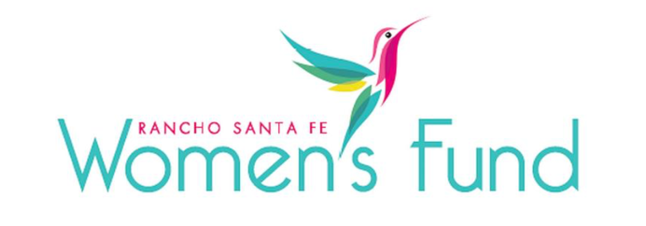

ORGANIZATION’S NAME: Home Start, Inc.
PROJECT NAME: Domestic Violence Survivor Program
ORGANIZATION’S WEBSITE: www.home-start.org
PROJECT BUDGET: $964,217
AMOUNT REQUESTED FROM RSFWF: $50,000
ORGANIZATION’S ANNUAL BUDGET: $11,946,813

PROGRAM DESCRIPTION: To provide flexible financial assistance to female victims of domestic violence in San Diego City and North County. The organization gets contracts from local municipalities, law enforcement agencies, and community partners to identify and provide services to women in need. A grant of $50,000 would represent 5% of the total Domestic Violence Survivor Program Budget. Per their three government contracts, Home Start is required to raise a minimum of matching funds from private foundations and individuals. Their existing government contracts do not provide enough flex funding to be able to meet all the needs of female survivors turning to us for assistance. The RSFWF grant would address this deficiency.

NEED/SOLUTION: By providing safe, secure housing and wraparound supportive services for victims of Domestic Violence, this program directly responds to the urgent need of assistance to women fleeing domestic violence. RSFSF funds would be used for security deposit and rental assistance, utility payments, transportation, school supplies, payment of credit card debt from an abuser, work-related clothes, uniforms, and items for infants. Assistance is provided based on need. Need is classified as Light, Middle, and Heavy Touch Assistance. Light Assistance includes one-time services such as changing a lock, paying for a vehicle repair, making a utility payment, or assisting with temporary childcare. Medium Touch Assistance includes in-person advocacy for connections to other services such as legal services, support groups, or counseling. It also involves assistance to retain or quickly obtain housing. High Touch Assistance includes substantial survivor-centered in-person advocacy and longer-term financial assistance to quickly obtain housing and achieve stabilization. Rental assistance is the most common need.

IMPACT: Based on their 13-year history of running housing programs, they expect to serve 120 female survivors (PLUS their 100+ children for parenting victims) in calendar year 2024, the majority being in San Diego City and North County San Diego. According to a SANDAG Crime in San Diego 2021 report, “In the San Diego region in 2021, 18,185 domestic violence incidents were reported to law enforcement, an increase of 3% from 2020.” Additionally, a report presented to the SD City Council in March 2022 stated that crimes involving domestic violence and guns increased 70% year-over-year. Our impact would be assisting these women in rebuilding their lives independently and preventing future abuse.

SITE VISIT DETAILS
RSFWF Site Visit Leader: Mary Consalvi
Date/Time: Wednesday, March 6th at 1:00 PM

