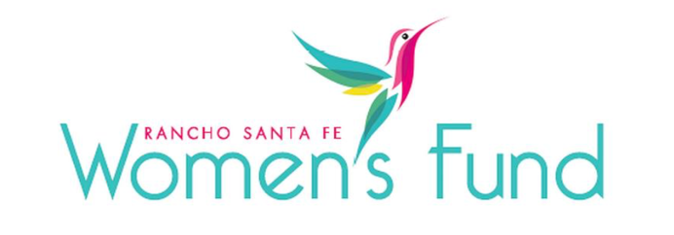

ORGANIZATION’S NAME: Interfaith Community Services
PROJECT NAME: Emergency Housing Program for North County Families
ORGANIZATION’S WEBSITE: https://www.interfaithservices.org/
PROJECT BUDGET: $1,258,484.00
AMOUNT REQUESTED FROM RSFWF: $75,000
ORGANIZATION’S ANNUAL BUDGET: $26,367,358

PROGRAM DESCRIPTION: Interfaith's Emergency Family Housing Program in Escondido is designed with the needs of families in mind by offering a safe, stable environment for the whole family, with private rooms, on-site meals, recreation areas, and indoor/outdoor play areas.

NEED/SOLUTION: Last fiscal year ending June 30, 2023, Interfaith served 20,250 unique individuals, including 14,387 adults, 5,863 children, 694 veterans, and 3,585 seniors. Hence, the NEED is great! Their solution includes offering more than 75 programs to provide comprehensive care, including emergency shelter, transitional housing, rapid rehousing, permanent supportive housing, recuperative care, substance use disorder treatment, employment services, homelessness prevention, multiple models of case management, homeless outreach, basic needs, behavioral health counseling, and referral and advocacy.

IMPACT: For the wider community, the project intends to
- increase the number of available shelter beds to provide 40 families and their children shelter services
- reduce the number of families experiencing homelessness in North County by providing 60% of enrolled families with stable housing
- provide a model of evidence-based solutions to family homelessness with access to behavioral health assessments, counseling, and age-appropriate children’s activities to support their healing from the trauma of homelessness

SITE VISIT DETAILS
RSFWF Site Visit Leader: Muffy Walker
Date/Time: Monday, March 11 at 1 PM

