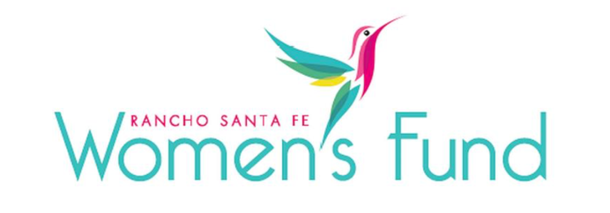

ORGANIZATION’S NAME: Just in Time for Foster Youth (JIT)
PROJECT NAME Wholistic Wellness Services for Young Women Impacted by the Foster Care System
ORGANIZATION’S WEBSITE: www.jitfosteryouth.org
PROJECT BUDGET: $437,333
AMOUNT REQUESTED FROM RSFWF: $50,000
ORGANIZATION’S ANNUAL BUDGET: $6,919,813

PROGRAM DESCRIPTION: Young women impacted by foster care have an uphill battle to access quality mental health care and overcome the tragic outcomes that typically befall them. Just in Time for Foster Youth offers an array of community and individual healing options that lead to long-term wellness.

NEED/SOLUTION: When foster youth first engage with JIT, they are already facing major obstacles. This is not surprising, considering that transition-age foster youth must overcome a legacy of homelessness, pregnancy, incarceration, sex trafficking, and lack of education and employment. Mental health care is an urgent basic need for the health of these young women, for the well-being of their current and future children, and for a healthier community.

IMPACT: JIT is requesting a $50,000 investment in their mental wellness services for young women, recognizing that reliable access to a variety of healing options can be the difference between a lifetime of anxiety and chronic illness or a healthy, self-sufficient future. This project will serve young women ages 18-26 who were impacted by the foster care system. JIT plans to serve 240 women across all wellness services. This program has two key parts:

My Life My Story will look at the ways that young women view themselves as women and their place in the world. This program will take place over a 9-month period with their female peers and coaches, providing encouragement and inspiration to address and mitigate the self-limiting beliefs and habits that resulted from a traumatic childhood. Intended impacts include defining themselves, their power, and their future; having the capacity to overcome past trauma and current obstacles; cultivating effective interpersonal skills to create positive, supportive relationships; and being enriched by gaining knowledge and giving back to make a real impact on the lives of others. Workshops include Saboteurs, Communication, Emotion, Healthy Relationships, Sexual Health and Intimacy, Confidence, and Femininity.

Mental Wellness Therapy is provided by a full-time clinical psychologist on-site who oversees 6-8 doctoral students from Alliant University who earn their hours toward their degree; it’s a win/win for all because participants get access to free quality trauma-informed therapy and the doctoral students gain the experience they need to earn their degree. The fact that they are generally in their 20’s with diverse ethnicities and backgrounds adds to their approachability and credibility.

SITE VISIT DETAILS
RSFWF Site Visit Leader: Kathy Stumm
Date/Time: Thursday, February 29th at 1:00 PM

