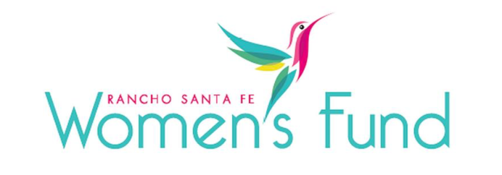

ORGANIZATION’S NAME: T.E.R.I., Inc.
PROJECT NAME: T.E.R.I. Campus of Life: Expanding Arts and Education for Special Needs Community
ORGANIZATION’S WEBSITE: https://www.teriinc.org/
PROJECT BUDGET: $15,000,000
AMOUNT REQUEST FROM RSFWF: $50,000
ORGANIZATION’S ANNUAL BUDGET: $33,674,146

PROGRAM DESCRIPTION: The TERI Campus of Life in North County is bridging San Diego's growing gap in adaptive programs for autism and neurodiverse disabilities by seeking philanthropic funds to complete the Campus of Life expansion in North County and dramatically increase access to evidence-based, inclusive education and art programs, fostering personal growth in self-expression, emotional awareness, social skills, and community belonging while celebrating each individual's special gifts.

NEED/SOLUTION: According to the CDC, 1 in 36 children are now diagnosed with Autism Spectrum Disorder (ASD). Most states focus on early detection and extensive early services. However, ASD is a lifelong condition, and many, if not most, adults with ASD need ongoing services and support. For over 43 years, T.E.R.I. has been a pioneer of best-practice, evidence-based services that address the complex life span of neurodiverse needs, supporting individualized plans that span the full spectrum of developmental, behavioral, and educational needs. With 12% of individuals and families in San Diego caring for family members with autism and other intellectual and developmental disabilities, T.E.R.I. serves and aligns with RSFWF’s mission in addressing the urgent needs of our community. The T.E.R.I. Campus of Life is a long-term project that is dramatically changing the way San Diego and the world see, help, and empower individuals with autism and other special needs.

IMPACT: A $50,000 grant from RSFWF will directly support the Center for Arts and Adult Education (CAAE) project on the Teri Campus of Life expansion program where needs in audiovisual, theatre lighting systems, adaptive classrooms, and studio technology at the Performing Arts Center, dramatically expanding access for the special needs community to experience the high-value benefits of continuous education and the arts. These programs are part of 20 different T.E.R.I. options, all designed to integrate a holistic support approach that enriches the lives of students, teachers, families, and the local community. Project Budget & Community Support: T.E.R.I. has secured 95% of this $15 million philanthropic project. Our $50,000 grant from RSFWF provides 6.25% of the remaining $800,000 that completes this critical phase of growth. Most of all, our support is a practical and purposeful encouragement to San Diego’s underserved special needs community and empowers this model of an inclusive and empowering community that sees and values all members of society.

SITE VISIT DETAILS
RSFWF Site Visit Leader: Lisa Hwang
Date/ Time: Thursday, March 7th at 10:00 AM

