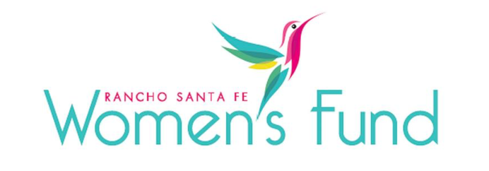

ORGANIZATION’S NAME: The San Marcos Promise (dba Project Next)
PROJECT NAME: Focused Futures
ORGANIZATION’S WEBSITE: www.projectnext.org
PROJECT BUDGET: $228,023
AMOUNT REQUESTED FROM RSFWF: $57,005
ORGANIZATION’S ANNUAL BUDGET: $1,181,234

PROGRAM DESCRIPTION: Focused Futures empowers students from socioeconomically disadvantaged backgrounds and other vulnerable youth to envision a promising future, find their paths, and develop the skills and confidence necessary to transition to meaningful career, training, and education opportunities.

NEED/SOLUTION: Many students have obstacles in their academic and personal lives that put them at risk of dropping out, disengaging from school, or struggling with employment and career options. Schools cannot provide the level of services these students need due to limited resources and 450:1 high school counselor caseloads. Focused Futures directly addresses the challenges that vulnerable students face. Services are provided in school settings to eliminate barriers of transportation issues, time conflicts, needing to work, etc. Students learn how to create actionable steps and their own roadmaps for a self-sustaining and promising future.

IMPACT: This program positively impacts disadvantaged high school seniors who have been pessimistic and have had little hope for their future, kids, who aren’t considering college, feel challenged accessing the workforce, and who may turn to criminal alternatives. After a year-long program in their own school environment, students who otherwise might fall through the cracks find meaning and hope for their future. They develop lifelong skills to succeed in life, get help with financial aid if needed, visit companies that align with their skills, and gain confidence and experience in career options they might otherwise not be exposed to.

SITE VISIT DETAILS
RSFWF Site Visit Leader: Katherine Chapin
Date/Time: Thursday, March 14th at 1 PM

